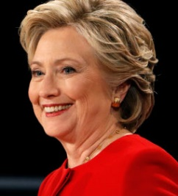
NOW PAC supports
HILLARY CLINTON
HILLARY is FIGHTING FOR US
- Increase the Minimum Wage

- Close Gender and Gender-Race Wage Gap
- Reproductive Justice, Affordable Health Care
- Paid Leave and Affordable Child Care
#NOW4Hillary
#StrongerTogether
#MsPresidentNOW

- Bring Down the Barriers of Systemic Racism
- Debt-Free College
- Full LGBTQ Equality
Visit nowpac.org
get involved in this HISTORIC ELECTION!

- Sensible Gun Laws
- Comprehensive Immigration Reforms
AND ... HILLARY NEVER QUITS
Paid for by NOW PAC and not authorized by any candidate.
National Organization for Women
1100 H Street NW, Suite 300
Washington, DC 20005

GOTV for this
Historic
Election!

#MsPresidentNOW

