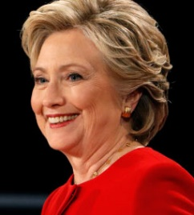
NOW PAC supports
HILLARY CLINTON
HILLARY is FIGHTING FOR US
- Increase the Minimum Wage
- Close Gender and Gender-Race Wage Gap
- Reproductive Justice, Affordable Health Care
- Paid Leave and Affordable Child Care
- Bring Down Barriers of Systemic Racism
#NOW4Hillary
#StrongerTogether
#MsPresidentNOW
- Debt-Free College
- Full LGBTQ Equality
- Comprehensive Immigration Reform
Visit nowpac.org
get involved in this HISTORIC ELECTION!
- Sensible Gun Laws
AND ... HILLARY NEVER QUITS

We MUST elect *WOMEN’S RIGHTS CHAMPIONS*

*GET OUT THE VOTE* FOR ALL THESE FABULOUS FEMINISTS!
Paid for by NOW PAC and not authorized by any candidate.

