Chapter Social Media Kit: Love Your Body 2014
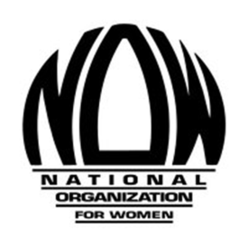

This social media kit is intended to provide easy-to-use social media for chapters to use in celebration of the NOW Foundation’s Love Your Body campaign. Though Love Your Body Day is October 14, these posts can be used at any time in the lead-up to #LYB2014!

Tweets:
What does love your body mean to you? Tell @NationalNOW what you think: http://j.mp/1sfzzFY #LYB2014

Love the #LYB2014 poster? Enter your own for #LYB2015. Rules and deadline here: http://now.org/now-foundation/love-your-body/posters/

.@NationalNOW wants to know what it means to you to "love your body" http://j.mp/1sfzzFY #LYB2014

Love the #LYB2014 poster? Get a copy of your very own: http://j.mp/19pKJLV Also available: 2013, 2009, 2005, and 2003 winners!

New from #SayItSister! “Hollywood & Diversity: How the Media Informs Social Identities” http://j.mp/1vOLSbl #LYB2014

Looking for an #LYB2014 activity? Watch NOW Foundation’s hangout from 2013! http://now.org/now-foundation/love-your-body/hangouts/

#LYB campaign was designed to challenge current beauty standards. What does it mean to you? Tell us: http://j.mp/1sfzzFY #LYB2014

Graphics:
How to use: Right click, with your mouse, on the image and "save as picture". You will need a copy of this image saved on your computer to upload to Facebook and Twitter.

Facebook: This picture won its category in the NOW Foundation’s 2014 Love Your Body poster contest. Click here to learn how to enter for 2015! http://j.mp/1sfE7ZW

Twitter: This won its category in NOW Fdn's Love Your Body poster contest. Click here to learn how to enter for 2015! #LYB2014 http://j.mp/1sfE7ZW
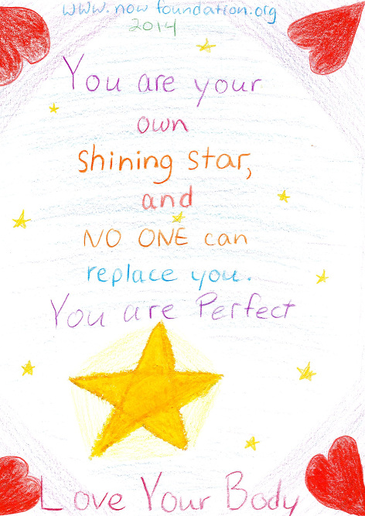
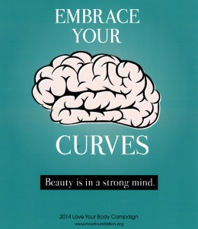

The following is for posting on October 14, 2014 – Love Your Body Day!
Facebook: Today is Love Your Body Day 2014! How are you celebrating? (Want a 2014 poster of your very own? It can be purchased here: http://j.mp/19pKJLV)

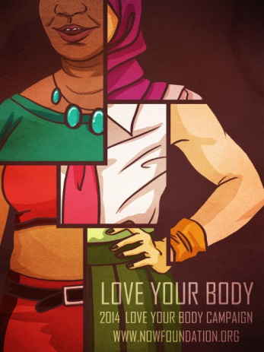
Twitter: Today is Love Your Body Day 2014 (#LYB2014). How are you celebrating? Get the 2014 poster here: http://j.mp/19pKJLV

