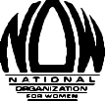

Contraception Mandate
Social Media Kit:
Hobby Lobby & the Dirty 100

March 25, 2014

Contraception Mandate: Hobby Lobby & the Dirty 100

Background:
The contraception mandate case, represented by the Hobby Lobby Corporation will be argued at the US Supreme Court on March 25, 2014. Use the below tweets, hashtags, and graphics and Twitter handles throughout the month of March to show your support for women’s access to contraception.

Theme:
Protect women’s reproductive rights and stand up against Hobby Lobby’s attempt at exemption from providing all forms of contraceptives to female employees.

Dirty 100:
The Dirty 100 are the one hundred anti-woman businesses, religious entities, and nonprofits that have come out of the woodwork and sued to block the contraception mandate in the Affordable Care Act. What does this mean? It means that these companies believe they can use their religion to justify discrimination against women.

Hashtags:
Use the below hashtags to show your support for women’s right to make their own reproductive healthcare decisions. Hashtags create solidarity on an issue across the social media world. Also, if you are using Hootsuite, be sure to follow these hashtags as well as use them in your tweets.

#Dirty100
#contraception
#birthcontrol

Tweet at Hobby Lobby:
@HobbyLobbyStores
@HobbyLobbyCase – Provides information and updates for their case v Sebelius

Tweet at the “Dirty 100”, companies and organizations like Hobby Lobby:

@avemariauniv @BeckwithCompany @BelmontAbbey @ConestogaWood
@CriswellCollege @DallasCath @DioceseFWSB @encompassddc @EdenFoods
@ErieDiocese
@ETBU @FranciscanU @frfrankpavone @GraceCollege @GroteIndustries @LA_College @LibertyU @MrWeingartz @NotreDame
@NRLC
@Ozinga @RandyReedBuick @siouxchief @Trijicon @TyndaleHouse @WheatonCollege
@FreshwayFoods @AFAchannel
@DioPitt
@archstl
@dordtcollege @followsnu @CatholicMiami @AveMariaLaw @Bishop_Farrell @JerryJrFalwell @apb_carlson
@dordtpresident @DrJamesCDobson @SNUPrezzy @WielandNow
@frfrankpavone
@cardinaldolan @BpOlsonFW @BishopGuillory

These twitter handles belong to Senators and Congressmen who support Hobby Lobby and the Dirty 100:
@SenOrrinHatch @SenThadCochran @MikeCrapo
@InhofePress @SenDanCoats @SenatorCharles
@McConnellPress @SenShelby @LamarSmithTX21
@RepWOLFPress @PatRoberts2014

Sample Tweets:
The #Dirty100 think want to dictate their employees’ healthcare. Tell them no! http://j.mp/1q6yCgF

Tell the #Dirty100 that #contraception is basic health care for women! http://j.mp/1q6yCgF

The #Dirty100 believe they can use their religion to justify discrimination against women. Tell them no! http://j.mp/1q6yCgF

.@HobbyLobbyStores you have the freedom to practice religion, not impose it on your employees #Dirty100

Don’t let the #Dirty100 take your reproductive healthcare decision out of your doctor’s office and into their own @HobbyLobbyStores @EdenFoods

A woman’s reproductive healthcare decisions should be made in her doctor’s office, not your boardroom @HobbyLobbyStores @EdenFoods @Trijicon @TyndaleHouse @WheatonCollege @FreshwayFoods

Women are people. For-profit corporations are not. @HobbyLobbyStores #HobbyLobby #Dirty100

Increased access to birth control = decreased need for abortion #HobbyLobbyStores #Dirty100

Plan B is not an abortion pill #HobbyLobbyStores #Dirty100

Employees NOT corporations have the right of religious freedom #HobbyLobby #Dirty100

End the war on women - don’t contribute to the #Dirty100 @HobbyLobbyStores @EdenFoods

98% of Catholic women have used #BirthControl #HobbyLobby

99%of US Citizens have used #BirthControl #HobbyLobby

Reproductive healthcare gone biblical #HobbyLobby #Dirty100

God Inc #HobbyLobby #Dirty100

.@HobbyLobbystore says part of his business is “treating our employees right” We beg to differ #Dirty100 #Birthcontrol

@SenOrrinHatch @SenThadCochran @MikeCrapo @SenDanCoats Condoms prevent fertilization are you against those too? #Birthcontrol #dirty100

Take Action By Signing the Petition:
Click here and act NOW to protect women's right basic reproductive healthcare

Or copy and paste into your brower: http://action.now.org/p/dia/action3/common/public/?action_KEY=9378

See next page for Dirty 100 Graphic

Dirty 100 Graphic:

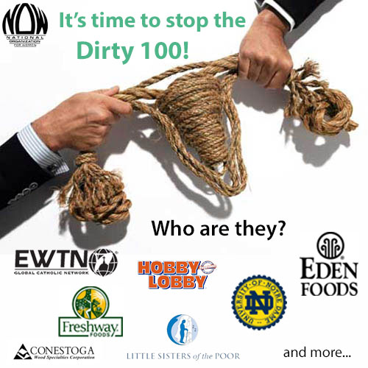

Facebook blurb for graphic:
Contraception is basic health care for women. But one hundred entities -- The Dirty 100 -- think otherwise. These businesses, religious entities, and nonprofits are suing to block the contraception mandate in the Affordable Care Act.
Let them know that you make your own healthcare decisions.
Not your boss. Not some bishop. Not some politician. You. http://j.mp/1q6yCgF

Tweet for graphic:
Who are the #Dirty100? http://j.mp/1q6yCgF

See next page for I Heart BC Graphic

I Heart BC Graphic:

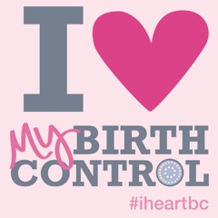
Facebook blurb for graphic:
Contraception is basic health care for women. But one hundred businesses, religious entities, and nonprofits are suing to block the contraception mandate in the Affordable Care Act.
Tell them “#Iheartbc!” http://j.mp/1q6yCgF

Tweet for graphic:
#iheartbc, so I’m taking a stand against the #Dirty100! http://j.mp/1q6yCgF

