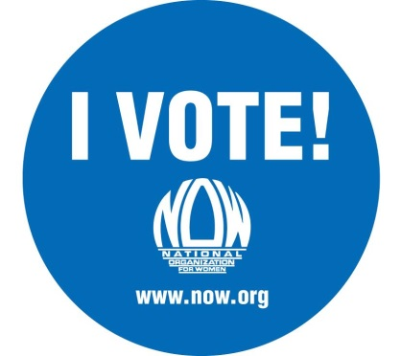
Dear NOW supporter,
This midterm, casting your vote will be crucial. A lot is at stake in the November 4th general election. We need to retain a majority of women's rights supporters in the Senate who can pass legislation that will positively impact the lives of women. A right wing majority would mean egregious bills such as the 20 week abortion ban would pass and great bills like the paycheck fairness act would remain bottlenecked.
And in [state/locality name], [ballot initiatives X, Y, and Z / candidate A] are necessary to advance the rights of [your state's] women. Brief description of ballot initiatives and/or candidates.
What you can do:
- Vote! Election Day(s) is/are [date(s)]. Polls are open from [time] to [time]. Ensure you are registered to vote and have [the appropriate identification in your state]. The registration deadline in [your state] is [date]. For more information, visit [the website of your local board of elections].
- Get active locally. [Information about your chapter's election related activities and how to get involved.]
- Educate your friends about how crucial this election is to protect reproductive rights, level the financial playing field, and move this country forward.

For Equality,
[your chapter]

