Know Your Rights:
Anita Hill & Sexual Harassment at Work

Purpose
The purpose of this social media kit is provide sample tweets, hashtags, Facebook posts and graphics to show support for the release of “Anita”, create dialogue about sexual harassment in the work place, and to educate people about what sexual harassment at work is & what your legal rights surrounding it are.

Hashtags
Use the below hashtags to help create a conversation on twitter about sexual harassment and promote Anita's story as an important part of that dialogue.

#WeStillBelieve
#AnitaHill

Statistics
31% of the female workers reported they had been harassed at work
7% of the male workers reported they had been harassed at work
62% of targets took no action
43% were harassed by a supervisor
27% were harassed by an employee senior to them
19% were harassed by a coworker at their level
8% were harassed by a junior employee

Follow and tweet questions at:
@ EqualRightsAdv

Tweets

7% of male workers reported that they had been harassed at work #AnitaHill #WeStillBelieve

1 out of three women report being sexually harassed at work #WeStillBelieve #AnitaHill

“[Sexual harassment] is really about power and using it” #AnitaHill #WeStillBelieve

43% of female reported that their harasser was a supervisor #AnitaHill #WeStillBelieve

No plans tonight? Go see Anita at your local theater! #AnitaHill #WeStillBelieve

Questions for Tweet Chat

.@EqualRightsAdv it’s been 22 years since Anita Hill. What’s changed? #WeStillBelieve #AnitaHill

.@EqualRightsAdv Is it sexual harassment if we are equals? #WeStillBelieve #AnitaHill

.@EqualRightsAdv What are my rights as an employee? #WeStillBelieve #AnitaHill

.@EqualRightsAdv What if they retaliate? #WeStillBelieve #AnitaHill

Share These Graphics:
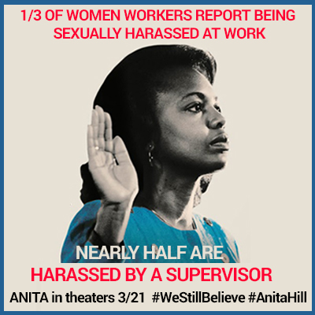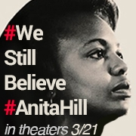
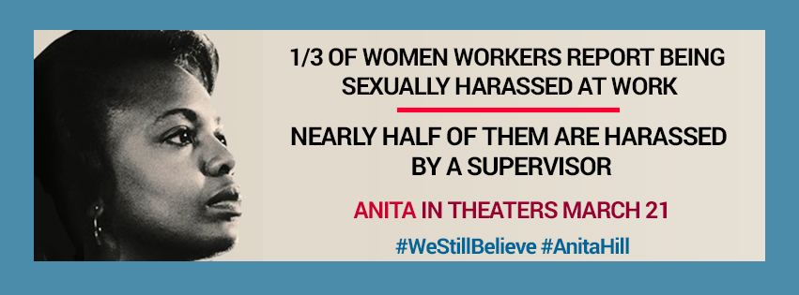

Caption for Facebook: We still believe Anita Hill and that everyone has the right to work in an environment free of sexual harassment. Share and show support for Anita Hill.
Caption for Twitter:
Sexual harassment is not part of your job description #WeStillStandwith #AnitaHill

